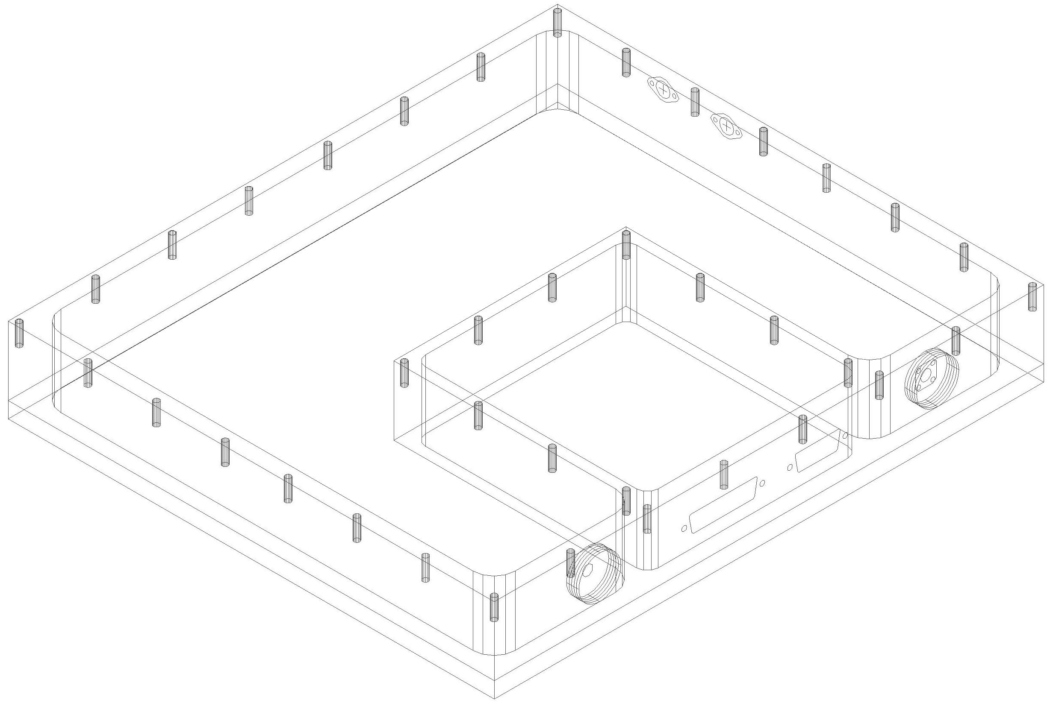
0.141″ from dewar
0.141″ from dewar
DB25 from dewar
DA15 from alidade
0.085″ to PAM w/ bulkhead connector
0.085″ to PAM w/ bulkhead connector
Control plastic fiber to alidade
SMF fiber to alidade/node
PAX Bulkhead connections
DRD – 11/14/03
DE9 cut-out

